***BAOFENG HT RADIO FIELD GUIDE***

**Charger LED Codes**

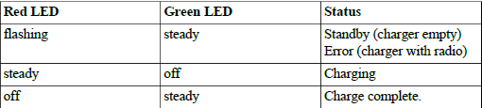

**Radio Button and Display Overview**

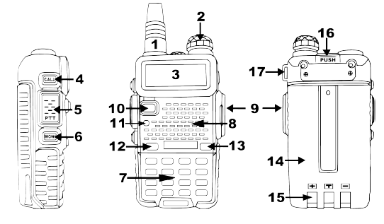

1. Antenna, see the section called “Assembly” for details.

2. Power / Volume knob, usage discussed in the section called “Power and volume”.

3. Two-line LCD

4. Call key

5. PTT key, usage discussed in the section called “Making a call”.

6. Monitor key

7. Keypad

8. Speaker and microphone

9. Accessory jack

10.VFO/MR mode key

11.Status LED

12.A / B select key

13.Band select key

14.Battery pack, see the section called “Charging and battery maintenance” for details.

15.Battery contacts

16.Battery release latch

17.Lanyard loop

18.LED flashlight, (not marked) situated between antenna and power/volume knob.

**Main Display**

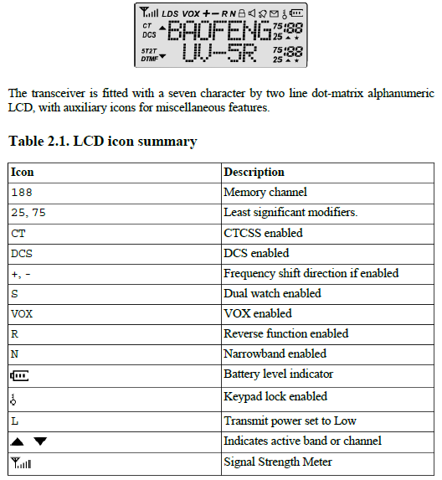

**Baofeng Accessory Jack**

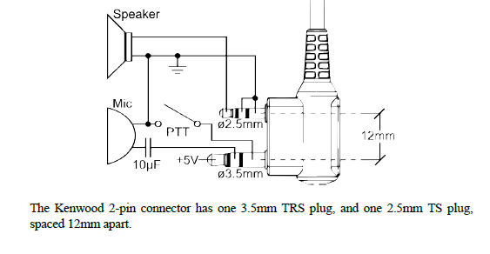

**Technical Specifications**

**General:**

***Specification*  *Value***

*Frequency Range (MHz)*  65-108 (Rx only)

136-174 (Rx/Tx)

400-480 (Rx/Tx)

*Memory channels* 128

*Frequency stability* 2.5ppm

*Frequency step (kHz)* 2.5 / 5 / 6.25 / 10 / 12.5 / 25

*Antenna impedance* 50 Ohm

*Operating temperature* -20°C to +60°C

*Supply voltage*  7.4

*Consumption* ≤75mA (standby)

380mA (reception)

≤ 1.4A (transmission)

*Mode of operation* Simplex or semi-duplex

*Duty cycle* 03 / 03 / 54 min. (Rx / Tx / Standby)

*Dimensions (mm)* 58 x 110 x 32

*Weight (g)* 214

**Transmitter:**

***Specification*  *Value***

*RF power (W)*  4 (UHF high)

4 (VHF high)

1 (UHF low)

1 (VHF low)

*Type of modulation* FM

*Emission class*  16K#F3E (wideband)

11K#F3E (narrowband)

*Maximum deviation (kHz)* ≤ ± 5.0 (wideband)

≤ ± 2.5 (narrowband)

*Spurious emissions (dB)* <-60dB

**Troubleshooting**

